ICS2O Programming Sep 4th, 2014

Downloading and Installing Python
Before we can begin programming you'll need to install software called the Python interpreter. The interpreter is a program that understands the instructions that you'll write in the Python language. Without the interpreter, your computer won't understand these instructions and your programs won't work. (We'll just refer to "the Python interpreter" as "Python" from now on.)
You can download Python from the official website of the Python programming language, http://www.python.org
Instructions for installing Python on Microsoft Windows:
When you get to python.org, you should see a list of links on the left (About, News, Documentation, Download, and so on.) Click on the Download link, Python 3.4.1 link, download page link, and then look for the file called Windows x 86-64 MSI Installer
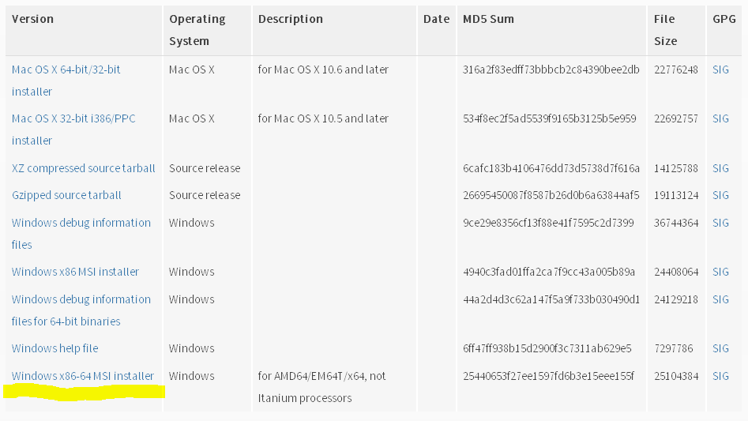
Figure 1: Click the Windows installer link to download Python for Windows from http://www.python.org

This file will work if you have 64–bit system. If you have 32-bit system, you should use Windows x 86 MSI Installer. To check what operating system you have go to Control Panel/ System

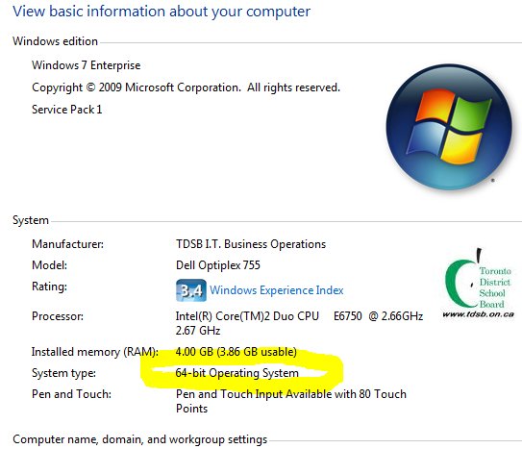

Figure 2: Check what operating system your computer has
Double-click on the Windows x 86-64 MSI Installer file that you've just downloaded to start the Python installer. (If it doesn't start, try right-clicking the file and choosing Install.) Once the installer starts up, click the Next button and just accept the choices in the installer as you go (no need to make any changes). When the install is finished, click Finish.
Important Note! Be sure to install Python 3, and not Python 2. We will use Python 3, and you'll get errors if you try to run programs with Python 2.
The installation for Mac OS is similar. Instead of downloading the .msi file from the Python website, download the .dmg Mac Installer Disk Image file instead. The link to this file will look something like "Mac OS Installer” on the "Download Python Software" web page.
If your operating system is Ubuntu, you can install Python by opening a terminal window (click on Applications > Accessories > Terminal) and entering sudo apt-get install python3 then pressing Enter. You will need to enter the root password to install Python, so ask the person who owns the computer to type in this password.

Starting Python
If your operating system is Windows XP or Windows 7, you should be able to run Python by choosing Start, Programs, Python 3.4, IDLE (Python GUI). When it's running it should looking something like Figure 1-2. (But different operating systems will look slightly different.)
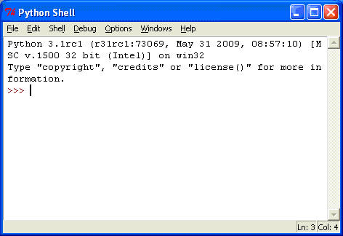
Figure 3: The IDLE program's interactive shell on Windows.
IDLE stands for Interactive DeveLopment Environment. The development environment is software that makes it easy to write Python programs. We will be using IDLE to type in our programs and run them.
The window that appears when you first run IDLE is called the interactive shell. A shell is a program that lets you type instructions into the computer. The Python shell lets you type Python instructions, and the shell sends these instructions to software called the Python interpreter to perform. We can type Python instructions into the shell and, because the shell is interactive, the computer will read our instructions and respond in some way. (Ideally in a way that we expect but that will depend on whether we write the correct instructions.)

